

Date: 13 ,December, 2024

Batch 54

Eagle IT LTD   
Company Overview

Lamesha Afaf Muntaka Oyshe

Contents

1 Executive Summery 2

2 Products and Services 2

2.1 Products: 2

2.2 Services: 2

3 Business Plan 3

3.1 Vision and Mission 3

3.2 Market Analysis 3

3.3 Marketing Strategy 4

3.4 Operations Plan 4

3.5 Financial Plan 4

4 Sales and Cost Statistics 5

# Executive Summery

Eagle IT LTD is a cutting-edge IT solutions provider specializing in innovative software development, IT consulting, and managed services. Our mission is to empower businesses with technology solutions that drive efficiency, productivity, and growth. With a team of highly skilled professionals, we aim to deliver exceptional value to our clients through customized and scalable IT solutions.

# Products and Services

## Products:

* **Desktops and Laptops:** [High-performance computers for personal and professional use.](https://www.ryans.com/category/laptop-all-laptop)
* **Servers and Networking Equipment:** [Reliable and scalable solutions for businesses.](https://www.ryans.com/category/desktop-pc--server-server)
* **Peripherals:** [Monitors, keyboards, mice, and other essential accessories.](https://www.ryans.com/category/cable--converter--hub)
* **Software:** Operating systems, productivity suites, and specialized software.

## ****Services:****

* **IT Consulting:** Expert advice to optimize your IT infrastructure.
* **Technical Support:** 24/7 support to resolve any technical issues.
* **Custom PC Builds:** Tailored computer systems to meet specific requirements.
* **Maintenance and Repair:** Comprehensive services to keep your equipment running smoothly.

# Business Plan

## Vision and Mission

* **Vision:** To be a global leader in IT solutions, recognized for innovation and customer satisfaction.
* **Mission:** To provide high-quality, reliable, and cost-effective IT solutions that meet the evolving needs of our clients.

## Market Analysis

* **Target Market:** Small to medium-sized enterprises (SMEs) across various industries.
* **Market Needs:** Efficient, scalable, and secure IT solutions to enhance business operations.

Vision and Mission

Market Analysis

Marketing Strategy

Operations Plan

Financial Plan

## Marketing Strategy

* **Brand Positioning:** Innovative, reliable, and customer-centric.
* 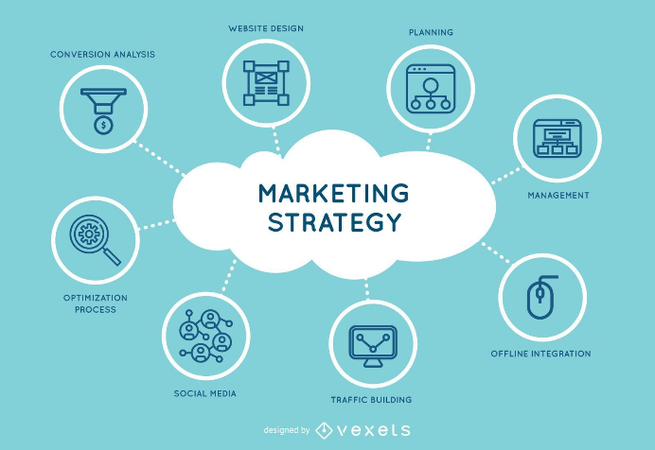**Promotion:** Digital marketing, industry events, and partnerships.

## Operations Plan

* **Location:** Headquartered in Huadu District, Guangdong, China.
* **Facilities:** Modern office space with state-of-the-art infrastructure.
* **Technology:** Latest software development tools and IT infrastructure.

## Financial Plan

* **Revenue Streams:** Software sales, consulting fees, and managed services contracts.
* **Cost Structure:** Salaries, office rent, marketing expenses, and technology investments.

# Sales and Cost Statistics

|  |  |  |  |
| --- | --- | --- | --- |
| **Year** | **Total Sales** | **Total cost** | **Total Profit/Loss** |
| 2020 | 6950000 | 5460000 | 1490000 |
| 2021 | 12250000 | 8000000 | 4250000 |
| 2022 | 6150000 | 5230000 | 920000 |
| 2024 | 3320000 | 2770000 | 550000 |